Uworld Behavioral and Social 5-23-21

Parallel Processing- brain’s ability to process several different components of a stimulus simultaneously.   
  
Piaget's theory of cognitive development (make individual cards)

|  |  |  |  |
| --- | --- | --- | --- |
| age | Stage | description | Developmental hallmark |
| <2 | Sensorimotor | Experiencing the environment via senses & actions | Object permanence  Stranger anxiety |
| ~2-7 | Preoperational | Representing real things with words & images | Pretend play  Egocentrism  Language development |
| ~7-11 | Concrete operational | Thinking logically about concrete events grasping concrete analogies preforming arithmetic | Conversation  Mathematical transformation |
| >12 | Formal operational | Thinking about hypothetical scenarios  Grasping abstract thoughts | Abstract logic  Moral reasoning develops |

Place theory- sound.   
explains the perception of sound pitch (high or low a tone is). Inside the cochlea, specific sound wavelengths generate basilar membrane vibrations at specific loci. Each locus (place) corresponds to a slightly different frequency. Hair cells located at the base of the basilar membrane are activated by high frequency sounds, and hair cells located at the apex of the basilar membrane are activated by low frequency sounds.   
  
Temporal lobe- contains multiple auditory cortices, involved in hearing, selective listening, language   
  
cultural relativism- there is no right or wrong cultural practices and is most inclusive of cultural differences and stereotype threat is less likely to occur.   
  
Common Sense-   
Stimulus -> subjective experience -> arousal -> conclusion: my heart is pounding because I am afraid.  
  
James- Lange -  
Stimulus -> arousal -> subjective experience -> conclusion: I am afraid because my heart is pounding.   
  
Cannon-Bard-  
Stimulus -> arousal AND subjective experience -> conclusion: my hear is pounding and the stimulus makes me feel afraid.

Schachter- Singer-  
Stimulus -> arousal -> interpretation -> subjective experience -> conclusion: my pounding heart signifies fear because I have appraised the situation as dangerous.

Universal emotions-  
happiness, sadness, fear, anger, disgust and surprise. Are expressed and detected by everyone, regardless of culture or nationality.  
  
Limbic system-   
network of brain regions involved in emotion, learning and memory.

Cingulate gyrus – emotional sensory input  
Thalamus – relays information   
Hypothalamus – homeostasis  
Hippocampus- memory consolidation   
Amygdala- primal emotions eg fear, anger, and sexual arousal  
  
basal ganglia-  
contain many dopamine-producing neurons, function to produce smooth, purposeful movements and inhibit excessive movement. Parkinson disease   
  
Cerebellum-  
lies below the cerebral cortex at the back of the brain, responsible for motor coordination and balance.   
  
Somatosensory cortex-   
located posterior to the lateral fissure in the parietal lobe. Region of the brain processes sensory information from touch and maps it to a specific area of the body.   
  
human components of emotion

|  |  |  |
| --- | --- | --- |
| Component | Description | Examples |
| Cognitive | Mental processes accompanying an emotion & involved in appraisal of the situation. | Thoughts  Beliefs  Expectations  Rationalization |
| Behavioral | Immediate outward reaction to an emotion that is involuntary & automatic. | Smiling  Gasping |
| Physiological | Bodily processes that accompany an emotion | Heart rate changes  Respiration rate changes  Sweating |

Neuroimaging methods

|  |  |  |
| --- | --- | --- |
|  | protocol | Measures |
| EEG | Electrodes placed on the scalp & connected to an amplifier | Electrical signals of the cortex below the skull |
| MEG | Helmet like device placed over head | Magnetic fields produced by brain activity |
| PET | Scanner detects radioactive tracer attached to a glucose analog | Glucose metabolism in the brain |
| fMRI | Scanner detects the differential properties of oxyhemoglobin & deoxyhemoglobin | Blood oxygenation in the brain |

Erickson’s stages of psychosocial development

|  |  |  |  |
| --- | --- | --- | --- |
| stage | ages | conflict | Successful resolution |
| Infancy | 0-1 | Trust vs. mistrust | Ability to have faith in others |
| Early childhood | 1-3 | Autonomy vs. shame/ doubt | Sense of self control & independence |
| Play age | 3-6 | Initiative vs. guilt | Ability to take imitative with peers |
| School age | 6-12 | Industry vs. inferiority | Sense of confidence in skills & abilities |
| Adolescence | 12-20 | Identity vs. confusion | Sense of self-identity |
| Early adulthood | 20-40 | Intimacy vs. isolation | Ability to commit to & love others |
| Middle age | 40-60 | Generativity vs. stagnation | Concern for others & society |
| Old age | >65 | Integrity vs. despair | Sense of accomplishment & fulfilment |

The **corpus callosum** is a bundle of myelinated axonal projections **connecting** the right and left **hemispheres** of the brain, allowing the two hemispheres to communicate.

The right and left hemispheres are **specialized** for certain processes, known as **cortical** **lateralization**.  Each hemisphere is responsible for **contralateral control** of the body:  The left hemisphere controls touch and movement on the right side of the body, and vice versa.  Each hemisphere is also specialized for certain cognitive processes.  The **left hemisphere** is specialized for **language** functions, including **speech production** (Broca area) and **language comprehension** (Wernicke area).

An **instinct** is an **innate**, **fixed** pattern of behavior that is more complex than a reflex, which is a simple response to a stimulus (eg, jerking hand away from hot stove).  Instincts are not based on prior experience or learning.  For example, newly hatched sea turtles instinctively know to move toward the ocean and swim.

**Instinctive** (or instinctual) **drift** describes an animal's **innate behaviors overshadowing a learned behavior**.  Animals can often be trained using operant conditioning, whereby a desired behavior is reinforced with a reward.  However, even when reinforcement is provided, trained animals will often revert to innate behaviors.

Language acquisition

|  |  |
| --- | --- |
| theory | Language acquisition |
| Learning perspective | Learned via  operant conditioning  Language imitation & practice |
| Nativist perspective | Innate & biologically predetermined occurs during a critical time- sensitive period in early life |
| Interactionist perspective | Biological (due to normal brain development)  AND social (due to interaction, reinforcement, desire/ motivation to communicate) |

**Reliability** refers to the **consistency** of an experiment or measure.

**Social loafing** occurs when an individual **exerts less effort** as a member of a group than when alone.  For example, studies show that people tend to applaud more loudly when alone than when part of an audience.

Causes of social loafing

|  |  |
| --- | --- |
| **Diffusion of responsibility** | As group size increases, individuals feel less responsible for the success of the group. |
| **Lack of motivation** | Individuals perceive their efforts as less influential on the overall group performance. |
| **Avoidance of over-effort** | No one wants to be the hardest working member of the group without being rewarded accordingly. |
| **Lack of oversight** | Without an arbiter recording each person’s effort, individuals feel able to get by with minimal effort. |
| **Non cohesive group** | When group members lack a sense of cohesion, social loafing is more likely to occur |

Oxytocin, a hormone produced by the hypothalamus and released by the pituitary gland, is involved in pair bonding, reproductive behavior, labor, and lactation.

The **hypothalamus** is centrally located in the brain and is the command center for the endocrine system, which produces hormones that regulate several of the body's functions, such as growth, metabolism, blood pressure, core body temperature, appetite, and sleep.

The hypothalamus has several nuclei (collections of neuronal cell bodies) that have specialized functions; one of these nuclei is the **suprachiasmatic nucleus (SCN)**, which regulates the circadian pacemaker that controls circadian rhythms.

Photoreceptors in the retina project information about light levels to the SCN.  When light levels are high, the SCN downregulates melatonin production by the pineal gland.  When light levels are low, the SCN upregulates melatonin production by the pineal gland.

**Longitudinal studies** involve collecting data over a period of time.  Longitudinal studies, which can be either experimental (in which a variable is manipulated) or observational, are useful for measuring how **variables change over time**.

McDonaldization describes when the following happens in society:

* **Efficiency** produces optimization at the **cost of individuality**.
* **Calculability** produces high quantities at the **expense of quality**.
* **Predictability** produces standardization at the **expense of uniqueness**.
* **Control** increases automation, **reducing** the need for a **skilled workforce**.

**Ethnography** is a qualitative method for the **scientific study** of **human social phenomena**.  Using observation and interviews, ethnographies study people in their natural environments (within their own communities) and provide descriptive information about the cultures, behaviors, norms, and values in a given geographic location.

**Parkinson disease** is associated with the **loss** of **dopaminergic neurons** in the **substantia nigra** (a structure in the basal ganglia that inhibits excess movement).  A dopamine deficit in the basal ganglia causes motor symptoms such as resting tremors (eg, shaky hands), muscle rigidity, and shuffling gait.

Many antipsychotic drugs are dopamine antagonists that work in part by blocking the action of dopamine, an excess of which in certain areas of the brain has been linked to psychotic symptoms (eg, hallucinations), such as those seen in schizophrenia.  These medications can have side effects that resemble the motor symptoms of Parkinson disease (eg, tremors, muscle rigidity).

**Top-down processing**, or conceptually driven processing, is **guided by** information, beliefs, or ideas already stored in our **brain**.  A mental association between objects that usually make sound, such as a telephone or a bell, may cause subjects to mistakenly believe they hear a tone even when none is present

**bottom-up processing**, or stimulus-driven processing, which is guided by **incoming data**, often sensory information

The **absolute threshold** is the intensity value at which an individual is able to **detect** the **stimulus 50% of the time**.

**Signal detection theory** quantifies how judgments or **decisions** are made under **uncertain conditions** amid "**noise**" (external or internal distractions).  This theory describes four possible outcomes, correct detection, false negative, false positive or correct rejection.

When a signal is correctly perceived as present, it is a **correct detection**, or a "hit."  When a signal is not detected even though it is present, it is a **false negative**, or a "miss."  When a signal is absent but a perception is erroneously reported, this is a **false positive**, and when the signal is accurately judged absent, this is a **correct rejection**.

According to **cognitive dissonance theory**, cognitive dissonance **(mental conflict)** results from beliefs, attitudes, or behaviors that are contradictory or incompatible.  Cognitive dissonance causes a **state of discomfort** that results in motivation to reduce the conflict by **aligning thoughts** and/or **behaviors**.

George Herbert **Mead**, who is most associated with the sociological theory of symbolic interactionism, argued that **social** (rather than biological) factors **influence identity formation**.  Mead suggested that the experience of "self" emerges through social interaction with others who play important and formative roles in one's life (eg, family).  The two aspects of the self are the "I" and "me," which develop in stages:

* **Preparatory** (or imitation):  Babies/toddlers imitate others (eg, a parent's hand gesture) and begin using symbols and language (eg, repeating a phrase used by a parent) without meaning comprehension.  At this stage, children have no sense of "self" as separate from the world around them.
* **Play**:  Through play (eg, pretending to be a doctor), preschool-age children begin **role-taking** (ie, understanding the perspectives of others).  When children understand themselves as individuals separate from others, the "I" component of the self has developed.  Children then begin to imagine how others perceive them, which is the beginning of the development of the "me."
* **Game**:  School-age children become aware of their position/role in relation to others.  They begin to see themselves from the perspective of the more abstract **generalized other**, further developing the "me" to incorporate the values and rules of the society in which they live.

**Anomie** is a state of **normlessness** that occurs when a society fails to provide individuals with norms and values to guide behavior.  In an anomic society, individuals lack guidance and purpose and feel aimless or alienated from society.  Anomie is often the result of a shift or transition in society that causes instability, undermining current norms (before new norms arise to replace them).

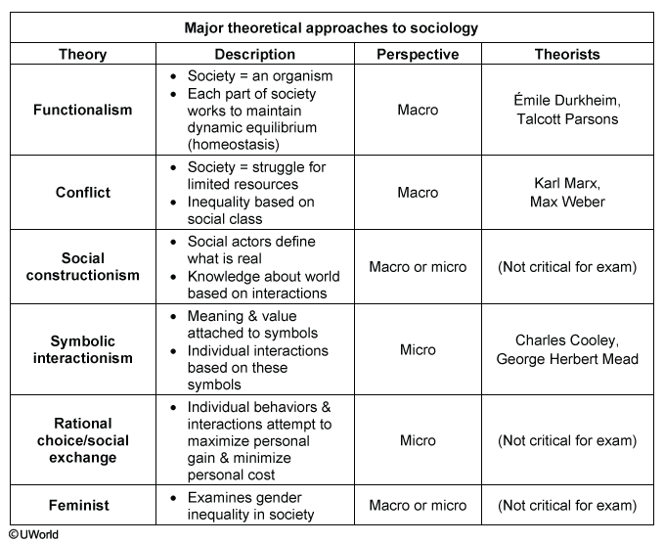

The major theoretical approaches in sociology view society from either a macro-level or micro-level perspective.  Theories with a **macro-level** perspective look at how larger social structures (eg, education and health care systems) function in society and impact the lives of those living in that society.  Theories with a **micro-level** perspective look at how interactions between individuals (eg, teacher and student, doctor and patient) shape society

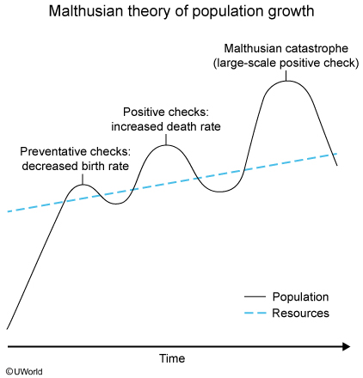

The **Malthusian theory of population growth** suggests that the human population increases exponentially while resources increase at a slower rate.  According to this theory, the population growth rate can be slowed by preventative checks and positive checks.

**Preventative checks** are those that decrease the birth rate (and are typically voluntary, such as waiting to marry and having fewer children).  **Positive checks increase** the death rate, slowing population growth by shortening the average life span.  Positive checks can be small-scale (eg, increased death rate due to a flu virus) or large-scale (eg, an epidemic that wipes out half the population).  Large-scale positive checks, called **Malthusian catastrophes** (eg, widespread famine, disease epidemics, large-scale wars), dramatically reduce the population to a level that the available resources can easily sustain, by slowing or stopping population growth entirely.

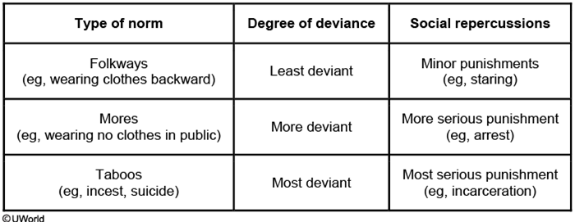

**Deviance** is any behavior that violates culturally established norms.  Deviant behavior can be viewed as simply odd or off-putting (eg, nose-picking in public) or can be viewed as egregious or criminal (eg, shooting someone).  Deviant behavior considered morally reprehensible by society is known as a **taboo**.  Suicide violates the major social script of protecting ourselves and trying to avoid pain, and is considered taboo in most societies.

Norms that dictate how to behave (also known as normative social scripts) exist in every culture and serve to disseminate information about appropriate conduct in a variety of situations.  Folkways are less formal social norms whereas mores are more formal social norms.  A violation of folkways (eg, walking outside with all your clothes on backward) is unlikely to draw more than a few raised eyebrows, but violation of mores (eg, walking outside naked) is likely to result in more formal punishment.

**Schizophrenia** typically involves both **positive symptoms**, which are "pathological excesses" (eg, hallucinations, delusions, disorganized speech), and **negative symptoms**, which are "pathological deficits" (eg, apathy, inability to experience pleasure).

Many people with schizophrenia also experience psychomotor symptoms (ie, changes in muscle tone or activity), which can occur either as a symptom of schizophrenia or as a side effect of medication.

 The **null hypothesis**, states that there is **no significant difference** or relationship between the variables measured.

Reinforcement increases (or maintains) behavior; **negative reinforcement** occurs when an **undesirable stimulus** is **removed**, which encourages a behavior to happen again.

Positive reinforcement occurs when a *desirable stimulus is* *applied*, which encourages a behavior to happen again.

Positive punishment occurs when an *undesirable stimulus is* *applied.*

Negative punishment occurs when a *desirable stimulus is* *removed*.

**Cognitive-behavioral therapy (CBT)** is a major therapeutic approach designed to help individuals **replace** **negative thoughts** and **behaviors** with **healthier** thoughts and behaviors.

|  |  |  |
| --- | --- | --- |
| **Major psychotherapeutic approaches** | | |
| **Cognitive-behavioral therapy** | **Psychoanalytic therapy ("talk therapy")** | **Humanistic therapy (person-centered therapy)** |
| Attempts to change negative thoughts/beliefs (cognitions) & maladaptive behaviors | Attempts to uncover how unconscious conflicts rooted in childhood shape behaviors | Attempts to empower individual to move toward self-actualization |
| Various techniques (desensitization, self-talk) used to replace destructive thoughts/behaviors with healthy ones | Various techniques (eg, free association, dream analysis) used to analyze unconscious | Unconditional positive regard & empathy used to encourage client to reach full potential |

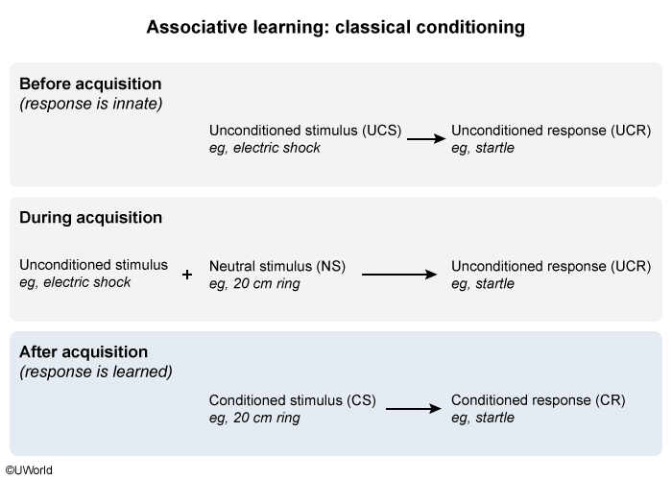

**Classical conditioning** occurs when a stimulus that did not previously elicit a meaningful response takes on the properties of a biologically arousing stimulus. For example, when a dog hears the sound of a bell every time it receives food, the sound of the bell alone will eventually produce salivation (eg, a meaningful response).

Unconditioned (ie, biologically arousing) stimuli cause **unconditioned responses** (ie, innate reactions). Neutral stimuli do not produce meaningful responses. After being paired with an unconditioned stimulus, the previously neutral stimulus becomes a **conditioned stimulus** when it causes the organism to react with a learned (ie, conditioned) response, which is typically similar to the unconditioned response.

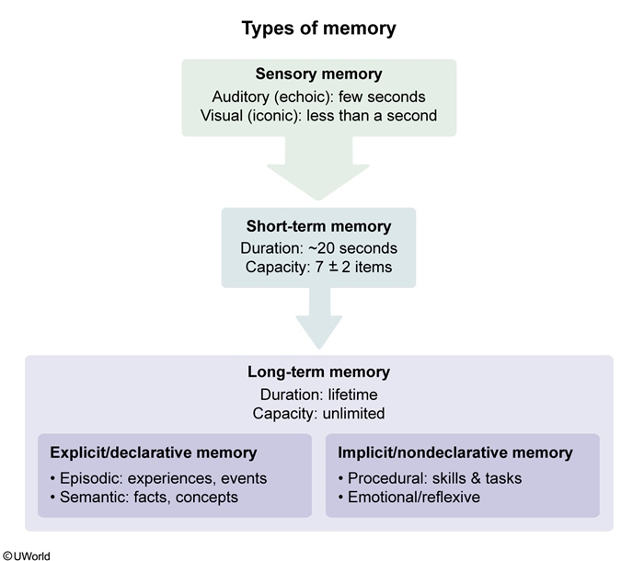

Research suggests that humans have two long-term memory systems, referred to as implicit and explicit. **Implicit/nondeclarative memory** is memory for things that **cannot** be **consciously recalled**, such as skills, tasks, emotions, and reflexes. Examples of implicit memory include:

* Procedural memory, which is memory for motor skills (eg, riding a bicycle) **(Choice B)**.
* Emotional/reflexive memory, which is memory for associations between stimuli (eg, salty ocean air triggers pleasant emotions from childhood beach vacations).

Classically conditioned fear responses are emotional, outside of conscious recall (ie, automatic/involuntary), and often elicit reflexive responses (eg, startle reflex). Therefore, the conditioned fear response during phase 2 occurs as a result of *implicit memory*.

**Stimulus generalization** occurs when the conditioned response is elicited by stimuli **similar to** the **original conditioned stimulus**. For example, an infant who has been conditioned to fear a white rat may also display fear in response to other stimuli, such as a white rabbit or white ball of yarn.